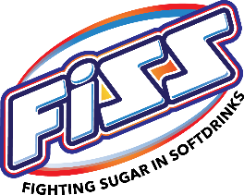
Revision Test 1

GROUP NAME: _______________________ CLASS: ____________
Members:

- How many grams of Sugar are there in a teaspoon of sugar?

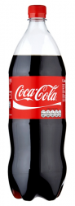
- Circle the number of teaspoons of sugar that are in each of these drinks.

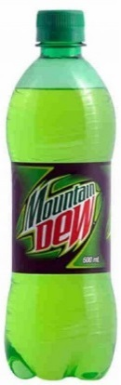
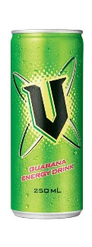
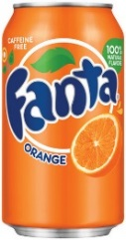
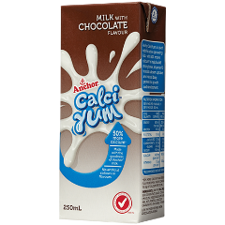
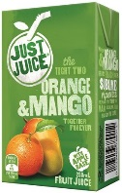

Just Juice  250ml | Calci Yum 250ml | V-energy  250ml | Fanta  330ml | Mountain Dew  600ml | Coke  1.5 L
2 tsp | 2 tsp | 2 tsp | 2 tsp | 2 tsp | 2 tsp
3-4 tsp | 3-4 tsp | 3-4 tsp | 3-4 tsp | 3-4 tsp | 3-4 tsp
5-6 tsp | 5-6 tsp | 5-6 tsp | 5-6 tsp | 5-6 tsp | 5-6 tsp
7-9 tsp | 7-9 tsp | 7-9 tsp | 7-9 tsp | 7-9 tsp | 7-9 tsp
10-12 tsp | 10-12 tsp | 10-12 tsp | 10-12 tsp | 10-12 tsp | 10-12 tsp
13-15 tsp | 13-15 tsp | 13-15 tsp | 13-15 tsp | 13-15 tsp | 13-15 tsp
16-19 tsp | 16-19 tsp | 16-19 tsp | 16-19 tsp | 16-19 tsp | 16-19 tsp
20-29 tsp | 20-29 tsp | 20-29 tsp | 20-29 tsp | 20-29 tsp | 20-29 tsp
30-39 tsp | 30-39 tsp | 30-39 tsp | 30-39 tsp | 30-39 tsp | 30-39 tsp
40-49 tsp | 40-49 tsp | 40-49 tsp | 40-49 tsp | 40-49 tsp | 40-49 tsp
50+ tsp | 50+ tsp | 50+ tsp | 50+ tsp | 50+ tsp | 50+ tsp

- Where do you find the information on sugar content of drinks?
(write here)

